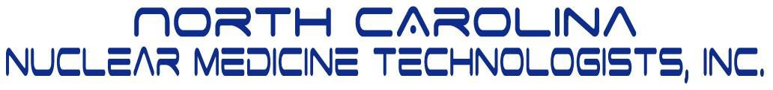

2018 Fall Meeting–Saturday September 22

Wake Forest Baptist Medical Center
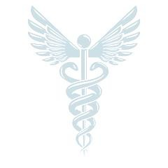
Babcock Auditorium Hawthorne St. WinstonSalem
Free Parking in Deck, Enter Below Crosswalk on Hawthorne

7:00 – 7:45 Registration
8:00 – 8:15 W E L C O M E & A N N O U N C E M E N T S

8:15 – 9:15 Hospitals are Soft Targets
David Howell, BS, RSO, Wake Forest Baptist

9:15 – 10:15 Nuclear Cardiolgy 101
Jean- Luc Urbain, MD Wake Forest Baptist

10:15 – 11:00 V E N D O R P A R A D E ** B R E A K

11:00 – 12:00 Emergency Management of NM Patients at a Large Institution
Christine Krieman, MS, Duke University Health System

12:00 – 1:00 Theranostics: An Evolution of Cancer Treatment
Michelle O’Neal, MHA,MBA,MSL,CNMT

1:00 – 2:00 LUNCH

2:00 – 3:00 Examining Quality Control in Nuclear Medicine
Jeffrey Nelson, MHP,DABSNM, Duke University Health System

3:00 -- 4:00 Read with the Doc: Renal Studies
Shane Masters, MD Wake Forest Baptist Health

